Editorial Manager online submission portal

1. Log into the submission portal via the Journal website. (The submission portal can be accessed via locating the “Submit Your Paper” or similar option.)
2. Select Author Main Menu.
3. Under the Completed heading, select the link Submissions with a Decision.

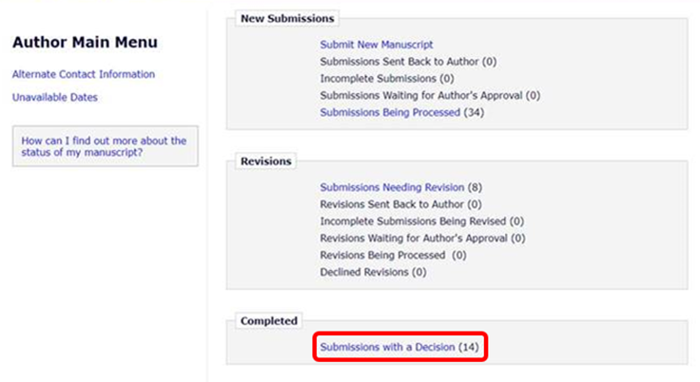

4. Locate the appropriate journal article and select the link View Submission. This will generate a PDF of the accepted manuscript the author provided to the journal.
The author accepted manuscript can usually be downloaded from submission systems until 2-5 years after publication, although this varies between journals.

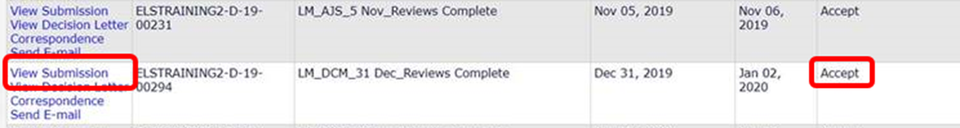

Please note: the information above is based on the public guidance provided to researchers by publishers and it might not apply to your specific context. To clarify what you can and cannot do with your journal article we recommend you also refer to your publishing agreement and related terms and conditions on the journal platform. This may help you ascertain whether the version obtained is the accepted manuscript.

