ScholarOne Online Submission Portal

1. Log into the submission portal via the Journal website. (The submission portal can be accessed via locating the “Submit Your Paper” or similar option.)
2. Click on the Author button located on the top left side of the page. This will redirect you to the author dashboard.
3. Click on Manuscripts with Decisions in the sidebar.
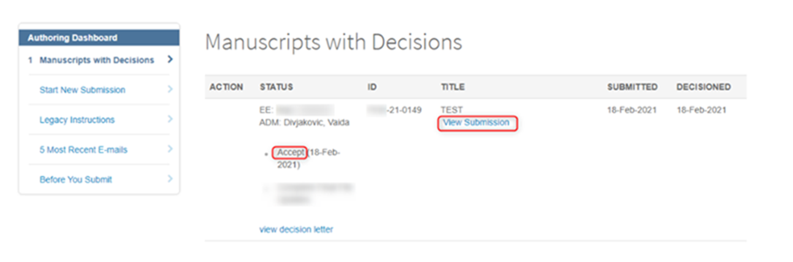

4. Click View Submission under the title of the appropriate manuscript. This will generate a PDF of the accepted manuscript you provided to the journal.
The author accepted manuscript can usually be downloaded from submission systems until 1-2 years after publication, although this varies between journals.

Please note: the information above is based on the public guidance provided to researchers by publishers and it might not apply to your specific context. To clarify what you can and cannot do with your journal article we recommend you also refer to your publishing agreement and related terms and conditions on the journal platform. This may help you ascertain whether the version obtained is the accepted manuscript.

