**How to access the Thesis Fest Networking Posters from the Blackboard link**

Click on the link: <https://lms.curtin.edu.au/webapps/blackboard/content/listContentEditable.jsp?content_id=_10371001_1&course_id=_131998_1>

Log into Blackboard using your Oasis details.

You will see this screen here:

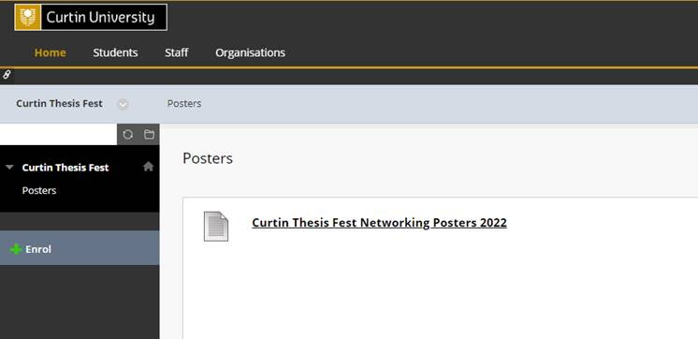

Click on the ‘Curtin Thesis Fest Networking Posters 2022’ link. You will see this screen here:

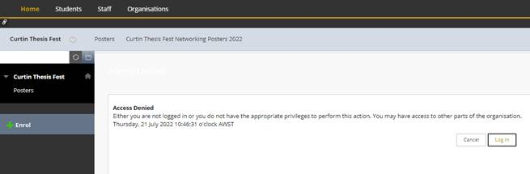

Click on the +Enrol link in the left hand navigation menu. You will see this screen here:

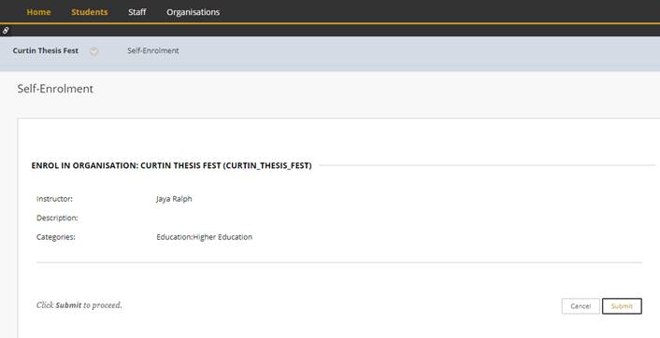

Click on the Submit button. You will see this screen here:

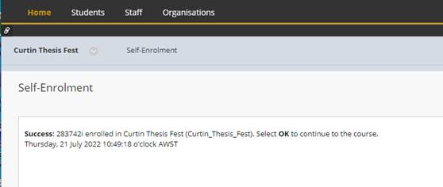

Click on the OK button.

You can now click on the ‘Curtin Thesis Fest Networking Posters 2022’ link to open the file.