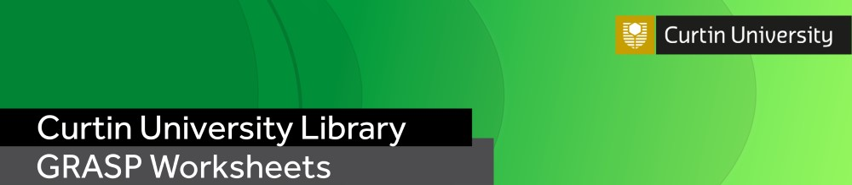

Research Writing Series
Better paragraphs

Writing can aid with clarifying your thoughts, so the purpose of this worksheet is to encourage you to start thinking and writing about your research and at the same time reflect on what you have learned in the corresponding GRASP workshop.

Part 1: Review

- What do you understand by the:
  - Purpose
  - Form/structure/length
  - Composition
of paragraphs in a doctoral thesis or exegesis?

- What do you understand by the M.E.A.L. approach to paragraph-writing? What do each of the letters of the acronym mean?

- What is the difference between deductive and inductive paragraphs?

- Kerri Wright proposes that “Each paragraph can be seen as a ‘mini essay’ with an introduction, a middle discussion part and a concluding sentence, which links to the next discussion point” (2010, p. 710). With both Wright’s statement and the M.E.A.L. approach in mind, analyse the following paragraph. Can you identify its “introduction”, “middle discussion”, and “links” or conclusion/consequence of the ideas discussed, and the ways it corresponds with the M.E.A.L. approach? Is this paragraph inductive or deductive?

It was chiefly in the eighteenth century that a very different conception of history grew up. Historians then came to believe that their task was not so much to paint a picture as to solve a problem; to explain or illustrate the successive phases of national growth, prosperity, and adversity. The history of morals, of industry, of intellect, and of art; the changes that take place in manners or beliefs; the dominant ideas that prevailed in successive periods; the rise, fall, and modification of political constitutions; in a word, all the conditions of national well-being became the subject of their works. They looked especially in history for the chain of causes and effects. They undertook to study in the past the physiology of nations, and hoped by applying the experimental method on a large scale to deduce some lessons of real value about the conditions on which the welfare of society mainly depended. (Lecky, The Political Value of History, cited in Strunk, 1979, pp. 17-18).

Part 2: Your project

- Now, try to apply what you have learned to your own writing. Take a paragraph from your own project (write or copy-and-paste it below) and then try to identify the following:
  - Is it a deductive or inductive paragraph?
  - How/does it correspond with the M.E.A.L. approach to paragraph-writing? (If it doesn’t correspond, can you identify what it does instead?)

- Take a paragraph from your work that you are having trouble with (write or copy-and-paste them below). First, try to identity what kind of issues you are having with this paragraph: in which way is it unclear or troubling? Then, consider the following:
  - Where is it located in the broader project?
  - What purpose does it provide your thesis/exegesis overall (e.g. how does it refer to your main claim), and how does it link to the paragraphs that come before and after it?
  - Does the paragraph maintain a consistent flow?
  - What does this section of your thesis/exegesis need you to discuss?
  - How many ideas are in this paragraph?
  - What structure does this paragraph take up (e.g. can you identify whether it is inductive or deductive)?

For more information and resources please visit the GRASP webpage. Send questions to the Library’s Research Services team at LibraryResearchSupport@Curtin.edu.au.

References
Strunk, W. Jr. 1979. The Elements of Style. Open Road Integrated Media. Pp. 17-18.
Wright, K. 2010. Simple writing skills for students, part one: Structure and clarity. British Journal of Nursing. 19(11). 709-711.

